RRTC on Advancing Employment for Individuals with IDD
State of the Science Paper – State level strategy and policy
Brief Summary
August, 2017
Introduction
Since the introduction of supported employment in the Developmental Disabilities Act of 1984 and the Rehabilitation Act Amendments of 1986, there has been continued development and refinement of best practices in employment services and supports. Progress includes demonstration of creative outcomes for individuals with significant support needs, including customized jobs and self-employment, community rehabilitation providers that have shifted emphasis to integrated employment, and states that have made a substantial investment in Employment First policy and strategy. Despite these achievements, the promise of integrated employment has not been realized for many individuals with intellectual/developmental disabilities (IDD). The number of individuals supported in integrated employment by state IDD agencies has remained stagnant over the past fifteen years, participation in non-work services has grown rapidly, and individual employment supports are not implemented with fidelity to a consistent model or expectations (Butterworth et al, 2016).
Responding to this need, the Rehabilitation Research and Training Center (RRTC) on Advancing Employment for Individuals with Intellectual and Developmental Disabilities is a research project housed at the Institute for Community Inclusion (ICI) at the University of Massachusetts Boston. It is part of ICI’s ThinkWork! initiative, a group of projects promoting community employment for people with IDD.
The RRTC’s work covers four main research strands:
Strand 1. Sharing knowledge with and supporting individuals and families around employment;
Strand 2. Increasing the effectiveness of employment consultants;
Strand 3. Building capacity and supporting organizational change for community rehabilitation providers;
Strand 4. Furthering policies and practices of high-performing state employment systems.
This brief covers Strand 4: Policies and Practices of High-Performing State Employment Systems.
BACKGROUND
Many factors color the national landscape around integrated employment including Employment First initiatives, CMS’s Home and Community-Based Services Final Rule, the application of Olmstead to employment settings, and the Workforce Innovation and Opportunity Act (WIOA). Despite the increasing emphasis on integrated employment and an Employment First philosophy, however, there remains a significant gap in employment rates between people with and without disabilities. The 2014 American Community Survey (ACS) estimates that 33.7% of working-age adults with disabilities are employed, compared with 72.9% of people without disabilities (Butterworth et al., 2016). Data from the National Core Indicators Project suggest that only 16% of working-age adults supported by state IDD agencies in 2014–2015 were employed in a paid job in the community (Hiersteiner, Bershadsky, Bonardi, & Butterworth, 2016). ICI research shows that an estimated 19% of individuals receiving day supports from state IDD agencies participated in integrated employment services during FY2014 (Butterworth et al., 2016), while participation in facility-based and non-work services has grown, suggesting that employment services remain an add-on rather than a systemic change (Nord et al., 2016; Butterworth et al., 2016; Mank, 2003; Domin & Butterworth, 2012).
With this data as background, participants in the 2015 National Goals in Research, Practice and Policy for and with People with Intellectual and Developmental Disabilities called for an “improved, comparative understanding of related policy (and) practice…inputs, (and their) resulting outcomes” and emphasized the need for alignment among systems (Nord et al, 2016). This research takes steps to address this charge by studying state employment systems’ policies and practices and their relationship to individual outcomes, and defining strategies of high-performing, collaborative state employment systems. To this end, analyses of higher performing states through composite indicator scores, case studies, and policy analysis is underway using the Higher Performing States Model as a foundation for exploration.
The Higher Performing States Model
The large variation in employment participation across state IDD agencies suggests that examining state agency policy and practice is vital for understanding employment outcomes. The Higher Performing States model (Figure 1) was developed over ten years ago from research that considered common strategies and approaches across state IDD agencies with high levels of integrated employment outcomes, and identifies seven elements that communicate commitment to the goals of community inclusion and integrated employment (Hall et al, 2007).
Figure 1. Higher-Performing States Employment Framework

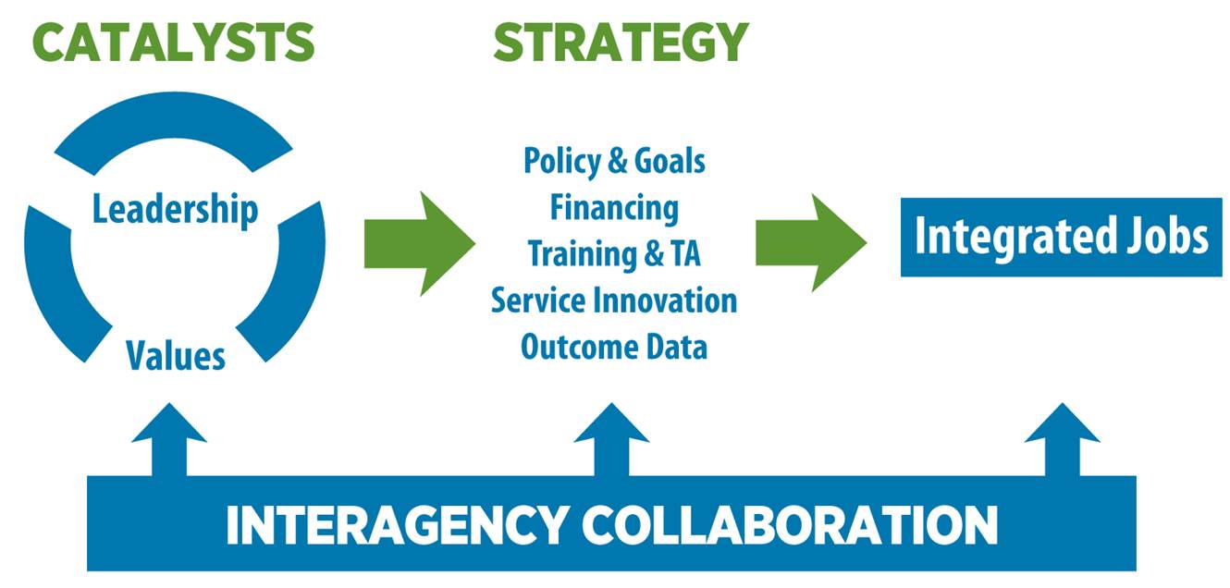
Given the current and increasing emphasis on a cross-systems focus and interagency collaboration, this model is evolving to encompass the systems interactions, relationships, and partnerships that characterize higher performing states. Building on this foundation of work on state systems and employment, project staff and partners in this research are exploring the relationships between state strategy and employment outcomes, with the goal of producing a framework where systems intentionally align practices with a priority for employment. We use several approaches including secondary analysis of national data sets (National Core Indicator analysis and the Employment Composite Indicator analysis), case studies of higher-performing state systems, and policy analyses that describe challenges and strategies of states as they respond to national priorities. This brief will summarize findings of each in turn.
National Core Indicator Analysis
To better understand service users, National Core Indicators (NCI) data from 25 states in 2012–2013 were analyzed to identify and describe individual demographic characteristics of individuals and their outcomes related to varied day and employment settings. Findings indicated that younger individuals were less likely to be in any employment setting, females were the most underrepresented group in the paid employment group, and those that had legal guardians were less likely to be employed (Nye-Lengerman, Pettingell, Nord, & Hewitt, under review). In general, individuals with IDD continue to receive services in non-work or facility-based employment programs at significantly higher rates than in community employment.
The State Employment System Performance Composite Indicator
The State Employment System Performance Composite Indicator was developed using data representing employment outcomes for state IDD agencies, state VR agencies, and state public education systems to create a composite indicator representing overall state employment system performance rankings.
The ten states with the highest-performing state systems in 2013 as evidenced by State Employment System Performance Composite Indicator scores, in ranked order, were Maryland, New Hampshire, Vermont, Oregon, Washington, Iowa, Oklahoma, South Dakota, Colorado, and Delaware (see Figure 2). Six of the higher-performing states were top performers in the IDD system: Maryland, New Hampshire, Vermont, Oregon, Washington, and Oklahoma. Due to a weighting criteria developed through an expert review and ranking of systems’ indicators, states that had higher IDD system performance rose to the top of the list for the State Employment System Performance rankings. Four of the 10 higher-performing states, Maryland, South Dakota, Colorado, and Delaware, were in the top 10 in terms of VR system performance. Four of the 10 higher-performing states were in the top 10 in terms of education system performance: New Hampshire, Iowa, South Dakota and Colorado. No single state scored in the top 10 in all categories. Next, researchers are creating a multivariate analytical model to explore the various inputs and attributes that contribute to state employment system performance to understand why some states showed indications of higher performance.
Figure 2. State Employment Systems Composite Indicator rankings

Case Studies of Higher Performing States
To understand what collaborative interagency policies and practices are being implemented in states with relatively high rankings in integrated employment and to contribute to the evolution of the research-based Higher-Performing States Employment Framework a case study of Maryland, the state identified as having achieved the highest ranking in the composite indicator analysis, was conducted.
Preliminary findings suggest that Maryland’s employment system emphasizes collaboration across agencies, within agencies, and among individuals that keeps employment outcomes as a key focus in the system. Success over the long-term depends on a cadre of stakeholders and their personal relationships and commitment to employment. In Maryland, leadership seemed to be most effective when distributed across multiple levels of responsibility. Finally, consistent allocation of funds for long-term services for youth exiting schools is critical and has cemented expectation for collaboration between school and adult service systems. Further analysis will focus on communication, culture, and the more granular elements of collaboration within the system.
Diving deeper: Highlights from policy analyses
RRTC staff and partners conducted in-depth policy analyses of priority and emerging policy topics that impact employment outcomes and services for individuals served by state IDD agencies: 1) state application of 2011 CMS guidance regarding the intent and outcome of pre-vocational services; 2) developments and potential strategies to embed employment as a priority for support coordination/ case management in service plan development, implementation and follow-up; and 3) multi-system collaboration, seamless transition, and support for individuals across the lifespan (in development).
Policy analysis 1 examined state application of 2011 CMS guidance, considering findings from CO, NJ, and VT, where themes emerged in the policies, practices, and strategies being used to increase integrated employment. Each state demonstrated strong leadership, evident through setting values and direction, making and communicating commitments, focusing on collaborative action, and creating systemic change supporting employment as a priority. Additionally, these states promoted the value and importance of integrated employment, moving ahead regardless of state budget issues, and created the infrastructure within their systems for innovations.
Policy analysis 2 considered developments and potential strategies to embed employment as a priority for support coordination/ case management in service plan development, implementation and follow-up. The person-centered planning and settings components of the HCBS Final Rule can provide a strong foundation for support coordinators to further meaningful conversations with individuals, families, and support teams. States are finding new ways to improve the person-centered planning process that involve guidance, questions, and potential action steps for support coordinators to use with teams when a person is not working and has not expressed interest in a job, is not working but would like a job, or is working and seeking growth opportunities.
Policy analysis 3, in progress, will address strategies for interagency collaboration, with the goal of seamless transition throughout systems and across the lifespan.
Discussion
The composite indicator research that ranks state employment systems enables the identification of states that are performing higher relative to others, so that that as a field we can identify and seek to replicate promising practices. The higher performing state systems provide context to the factors that permit state IDD, VR, and education agencies to support a high percentage of individuals with IDD in employment. The description of policies and practices that occur within and across state agencies provides valuable information to support the implementation of both federal and state laws and initiatives to improve the economic outcomes of individuals with IDD. Preliminary findings from the Maryland case study suggest that there is a longitudinal component to state’s success which depends on state government stakeholders, the service provider community, and the advocacy community. Additional findings suggest that state agency policy and practices that specifically address how supports will evolve over time is an important component of building an Employment First culture.
The implications of the findings across this research strand focus on the ways in which systems change is a commitment that requires a long-term dedication to reframing how services are designed to support individuals to obtain their goals. This reframing will require changes not only across the IDD, VR, and education service systems but within community providers and throughout the direct support workforce that is implementing these services.
SOURCES CITED
Butterworth, J., Smith, F. A., Winsor, J., Ciulla Timmons, J. , Migliore, A., & Domin, D, (2016). StateData: The national report on employment services and outcomes. Boston, MA: University of Massachusetts Boston, Institute for Community Inclusion.

Domin, D., & Butterworth, J. (2012). The 2010-2011 national survey of community rehabilitation providers. Report 1: Overview of services, trends and provider characteristics. Research to Practice Brief. Boston, MA: University of Massachusetts Boston, Institute for Community Inclusion.

Hall, A. C., Butterworth, J., Winsor, J., Gilmore, D., & Metzel, D. (2007). Pushing the employment agenda: Case study research of high performing states in integrated employment. Intellectual and Developmental Disabilities, 45(3), 182–198.

Hiersteiner, D., Bershadsky, J., Bonardi, A., & Butterworth, J. (2016). Working in the community: The status and outcomes of people with intellectual and developmental disabilities in integrated employment--Update 2. NCI Data Brief, April 2016. Cambridge, MA: Human Services Research Institute.

Nord, D., Butterworth, J., Carlson, D., Grossi, T., Hall, A., & Nye-Lengerman, K. (2016). Employment of people with IDD: What do we know and where are we going? In Critical issues in intellectual and developmental disabilities: Contemporary research, practice, and policy. Washington, DC: American Association on Intellectual and Developmental Disabilities.

